SOP of Ajit Bakery

**For User Management:**

**Step 1.** Enter **Username** and **Password** to Login.

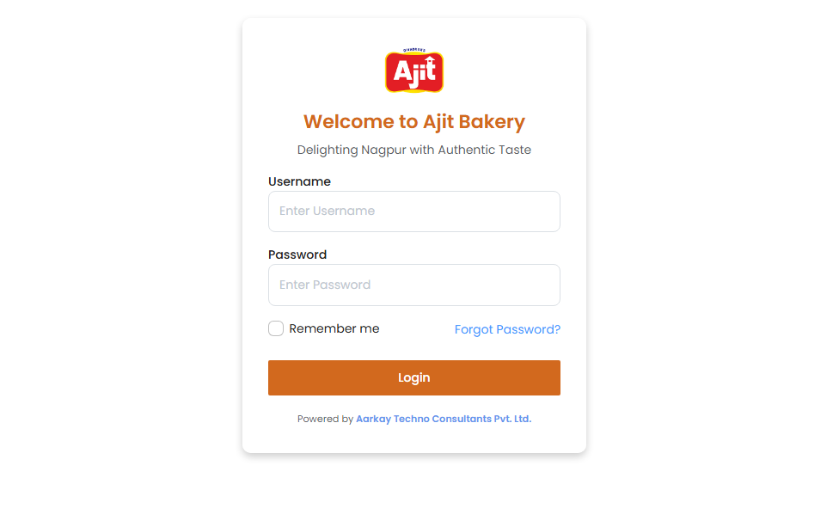

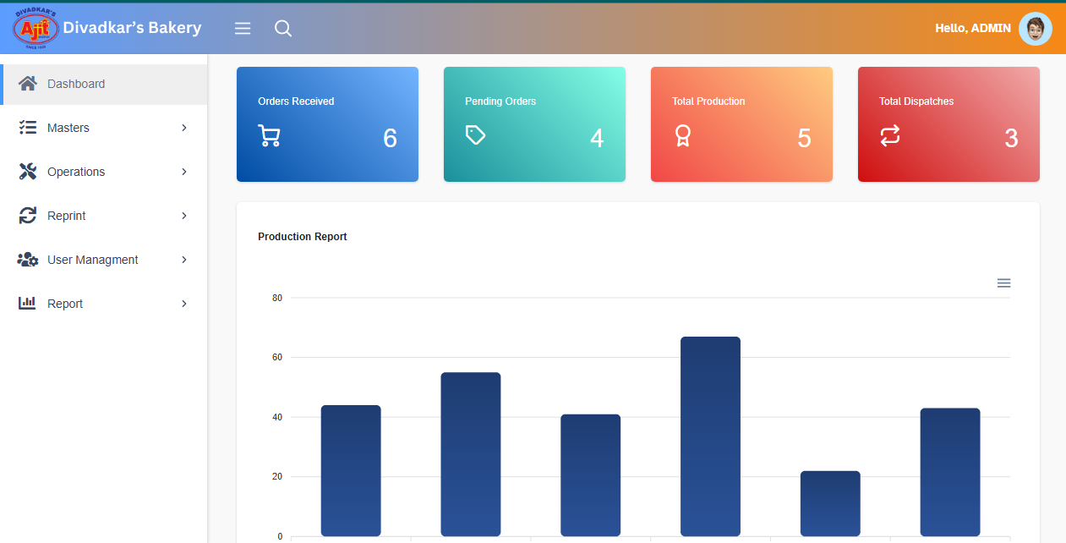

**Step 2.** Click on **User Management**

**Step 3.** Click on **Page Allot**.

**Step 4.** Click on **Edit**.

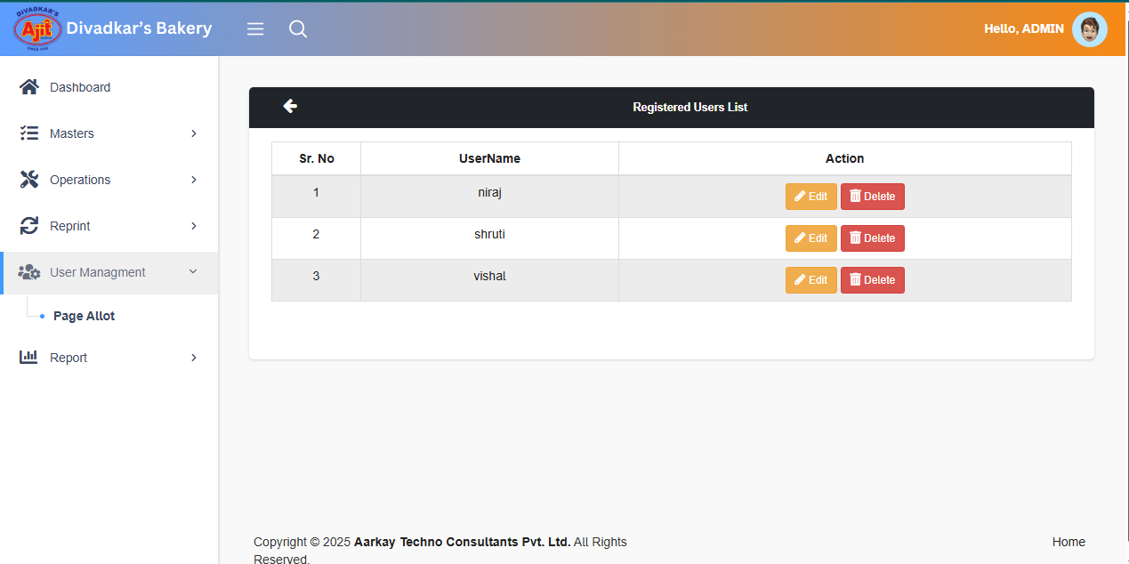

**Step 5.** Select Role from the dropdown.

**In Page Access**

1. **Under Admin-** Dashboard, Masters, Report, Operations, User Management, Reprint access rights
2. **Under Masters-** Product Master, Dial Master, Box Master, Outlet Master, User Master, Transport, Cake Designs access rights.
3. **Under Operation-** Packaging, Transfer To Dispatch, Production, Production Planning, Dispatch access Rights.
4. **Under Reprint-** Packaging Receipt and Item Sticker access rights.
5. **Under Report-** TAT Report, Order Status Report, Dispatch Report, Production Report access rights.

Click On **Save.**

